<https://desktop.github.com/>

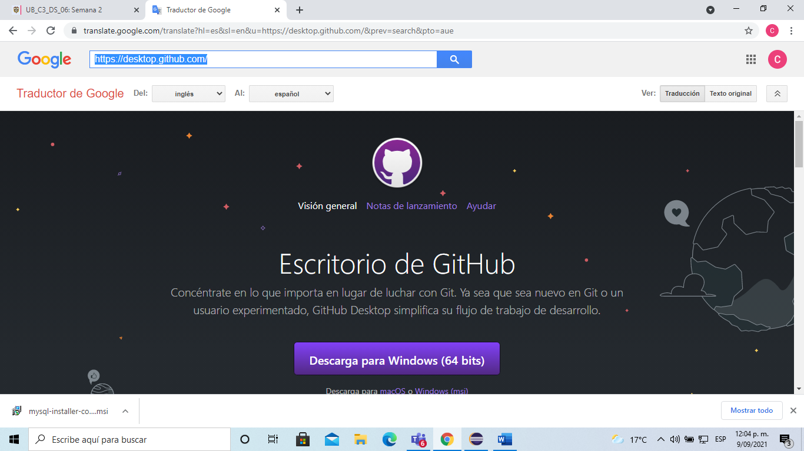

<https://docs.github.com/es/desktop/installing-and-configuring-github-desktop/installing-and-authenticating-to-github-desktop/installing-github-desktop>

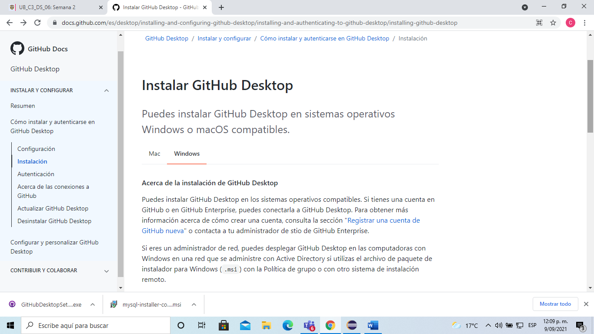

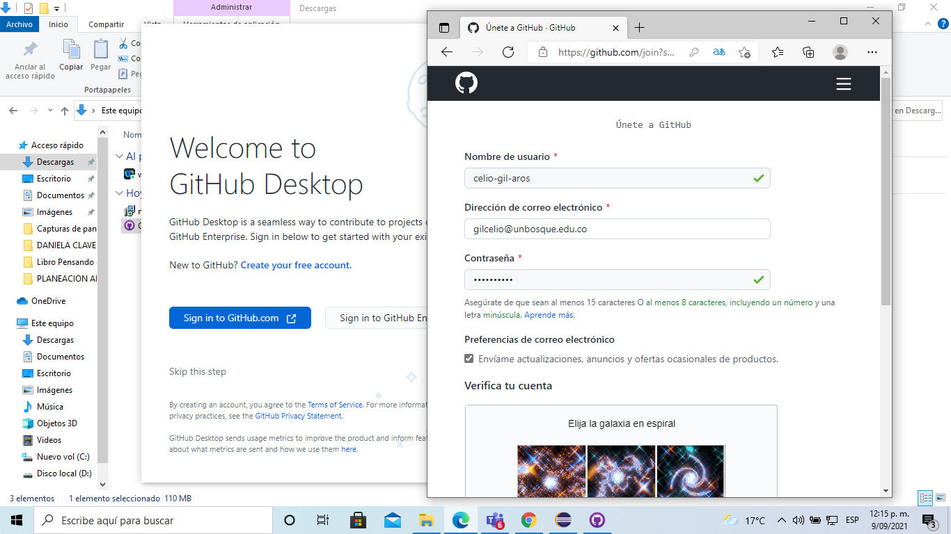

CREACION DEL REPOSITIORIO

